Top 5 NoSQL Databases Used for Data Analysis - NoSQL Databases
María José Quesada Alvarado

Computer Systems Engineering, Universidad Fidélitas
San Pedro, Montes de Oca, Costa Rica

Maria.quesada80349@ufide.ac.cr

Abstract— Data analysis goes hand in hand with databases, it is required to obtain a lot of knowledge in databases when you want to apply data science, data analysis, business analysis, among others. NoSQL databases are very popular in this industry.
The top 5 NoSQL databases used for data analysis are: MongoDB, Cassandra, Elastic Seacrh, Amazon DynamoDB, and Hbase.
Each of the aforementioned databases are adapted to different tasks that we may require, therefore, to choose the correct option, it is necessary to know its characteristics and what we are going to need.
Keywords— Database, No data analysis, MongoDB, Cassandra, Elastic Seacrh, Amazon DynamoDB, Hbase.

- INTRODUCTION
This document aims to show the non-relational databases most used for data analysis, giving different advantages to the analyst, facilitating day-to-day work. However, for this it is necessary first to understand the basic concepts but necessary to have the knowledge of what data analysis entails and its relationship with NoSQL databases. In addition, the power of databases within the world of analysis and big data will be explained in depth.
Furthermore, it is important to know when to use a relational database and when to use a non-relational one, because of this, the main aspects to consider will be detailed.
Having these topics explained, the top 5 NoSQL databases will be shown along with the functionality of each one. Adding to this, the reader will be guided to choose the correct database depending on the needs of the project, the different advantages of each one will be mentioned and examples of pages or well-known applications that use them will be provided. All this so that the reader can choose the database that best suits their needs.

- DATABASES AND DATA ANALYTICS
Data Analysis (DA) is the science that examines raw data in order to draw conclusions about the information. Data analysis is used in many industries to enable companies and organizations to make better business decisions and is also used in science to verify or disprove existing models or theories. [1]
The more data obtained, the more accurate the analysis can be. A good database can make the analyst job easier. This is why the analyst is required to have basic knowledge of databases to achieve his objectives.
Both relational and non-relational databases can be used for data analysis.
Many analysts duplicate operational information in an operational data warehouse, causing immediate problems on how to update stored information, fast enough to meet user requirements.
There will always be questions about performance impacts on the operational sources, and often security concerns as well. However, when comparing the types of queries possible for a NoSQL store or a document-oriented database, it is commonly acknowledged that normalizing data in a relational database provides a more query-friendly structure, which allows a wider variety of queries to be controlled. In the case of using an operational BI tool, queries are usually much simpler. [2]
While it is true, many NoSQL databases are not initially aimed at data analysis, such as MongoDB, however, they have been adapted in such a way that they can be increasingly useful in this field. MongoDB is currently working to enhance large-scale analytics capabilities that will help users perform analytics within the platform and convert data to graphs, as well as a parallel query execution engine and column storage format, which it will speed up the analysis by storing the data. in a more efficient way.

- NOSQL DATABASES FOR ANALYTICS
The top 5 popular databases used for analysis are as follows:
- MongoDB
MongoDB is a general-purpose, document-based, distributed database designed for modern application developers and for the cloud age. [3]
MongoDB instead of saving the data in logs, it saves the data in documents. These documents are stored in BSON, which is a binary representation of JSON.
With the MongoDB Connector tool for BI, included with MongoDB Enterprise Advanced, data from modern applications can be easily analyzed, this in conjunction with industry-standard SQL-based BI and analytics platforms.
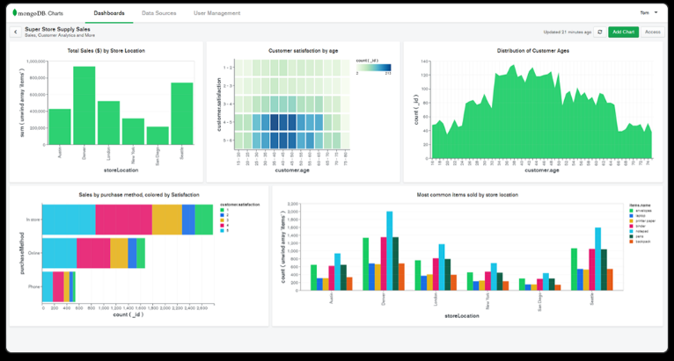
Business analysts and data scientists can successfully analyze the semi-structured and unstructured data managed in MongoDB, along with the traditional data in their SQL databases using the same BI tools implemented in millions of companies.
Image 1. Data Analysis with MongDB. Taken from: https://www.mongodb.com/analytics
With MongoDB the analyst can provide valuable information that the business demands and handle any new data source. With the only data model flexible enough for rich, modern data, a distributed architecture built for cloud scale, and a robust ecosystem of tools for each user, the MongoDB data platform helps break free from data silos so that innovation can be scaled.
In addition, some advantages of MongoDB for data analysis are the following:
- Flexible schema: MongoDB collections, by default, do not require your documents to have the same schema. This flexibility makes it easy to assign documents to an entity or an object. Each document can match the data fields of the represented entity, even if the document has substantial variation from other documents in the collection.
- Document structure: MongoDB allows you to embed related data in a single document. The key decision in designing data models for MongoDB applications revolves around the structure of the documents and how the application represents the relationships between the data.
- Atomicity of write operations: MongoDB supports multi-document transactions.
When to use MongoDB?
- In case the analyst is planning to integrate hundreds of different data sources, MongoDB's document-based model will be an excellent choice, as it will provide a single, unified view of the data.
- When the analyst expects a lot of read and write operations from your application, but don't care much that some of the data is lost in the server crash.
- The analyst can use it to store click stream data and use it for customer behavior analysis.

- Cassandra
An Apache Cassandra database consists of open-source software running on one or more physical or virtual computer servers known as a Cassandra cluster. It also refers to data stored within the database in the formats and accessed over the Internet via query languages and methodologies specified by the Apache Cassandra project. There is an active Apache Cassandra community where users discuss usage and latest developments. [4]
Cassandra is used in real-time data analysis as it is excellent for storing and querying large amounts of high-performance data.
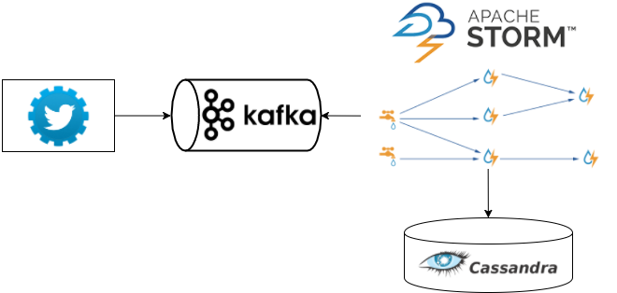
Cassandra has a natively integrated tool, called Knowi, used so that you can take advantage of the full query power of Cassandra to visualize large amounts of data quickly. Knowi offers scale and speed, on top of its modern data stack that includes Cassandra.

Image 2. Analysis of twitter streams with Kafka and Storm. Taken from: https://serrate.net/2016/01/05/analysis-of-twitter-streams-with-kafka-and-storm/
In addition, some advantages of Cassandra for data analysis are the following:
- The drag and drop query interface automatically generates CQL, this allows you to quickly start creating queries making the analyst's work faster with results in a short time. With Knowi, you don't need to know the underlying query language, create data models, or define schemas.
- Casandra carries broader native integration for NoSQL data sources alongside SQL, REST-API, and JSON / CSV.
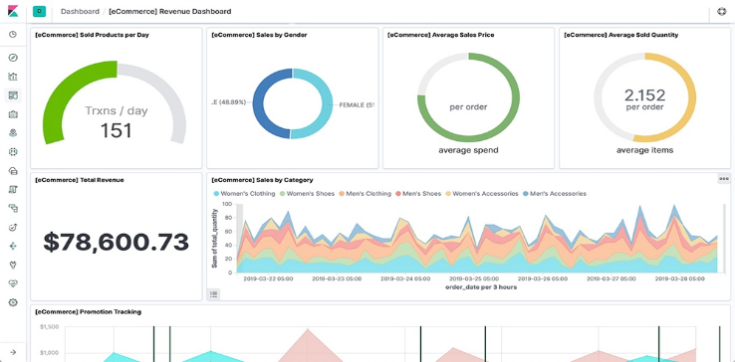
- Cassandra has over 30 visualizations for business users to customize their own Cassandra dashboards or create new ones from a master without changing the underlying query. They simply run ad-hoc analysis and create their own Cassandra KPI dashboards for clients.
- Users can share Cassandra dashboards or PDF reports via email to extend analytical reports across the company.
- Ability to add machine learning to your Cassandra queries.
- With Trigger Notifications, the analyst can automate actions or notifications based on the results of Cassandra advanced analytics queries.
When to use Cassandra?
- When the use case requires more writing operations than reading ones.
- In situations where the analyst needs more availability than consistency. For example, you can use it for social network websites but cannot use it for banking purposes.
- The analyst requires a smaller number of joins and aggregations in your queries to the database.
- Health trackers, weather data, tracking of orders, and time series data are some good use cases where you can use Cassandra databases.

- ElasticSearch
Elasticsearch is a free, open, distributed analytics and analytics engine for all types of data, including textual, numeric, geospatial, structured, and unstructured. Elasticsearch is built on Apache Lucene and was first introduced in 2010 by Elasticsearch N.V. (now known as Elastic). Known for its simple REST APIs, distributed nature, speed, and scalability, Elasticsearch is the core component of the Elastic Stack, a set of free and open tools for data ingestion, enrichment, storage, analysis, and visualization. Commonly referred to as the ELK Stack (after Elasticsearch, Logstash, and Kibana), the Elastic Stack now includes a large collection of lightweight agents known as Beats to send data to Elasticsearch.[5]

Image 3. Elasticsearch analytics. Taken from: https://www.elastic.co/es/what-is/elasticsearch-business-analytics
In addition, some advantages of Cassandra for data analysis are the following:
- More detailed visualization of your data with the Elastic Stack, a scalable cross-platform analytics engine.
- The analyst will be able to combine everything with Elastic Stack, from ingesting social media documents for sentiment analysis to summarizing unique KPIs to uncover hidden trends.
- You can analyze data on the fly with drag-and-drop functionality, instant previews, and smart suggestions. Additionally, ad hoc exploration can be performed as the data takes shape.
- It allows you to generate PDF with design for the team and allows you to schedule updates on a regular basis for customers. It is possible to receive raw data and documents for audiences that require more than just the summary, as well as send the dashboards to the inboxes of everyone who needs them.
- It allows to identify problems before they impact the business.
When to use ElasticSearch?
- If the use case requires a full-text search, Elasticsearch will be the best fit.
- If the use case involves chatbots where these bots resolve most of the queries, such as when a person types something there are high chances of spelling mistakes. The analyst can make use of the in-built fuzzy matching practices of the ElasticSearch.
- Also, ElasticSearch is useful in storing logs data and analyzing it.

- Amazon DynamoDB
Amazon DynamoDB is a key-value and document database that delivers single-digit millisecond performance at any scale. It is a fully managed, durable, multi-region, multi-region database with built-in backup, restore, and security, as well as in-memory caching for Internet-scale applications. DynamoDB can handle more than 10 trillion requests per day and can support peaks of more than 20 million requests per second. [6]
With DynamoDB, you can export data to Amazon S3, and you can use other AWS services, such as Amazon Athena, to analyze your data and extract actionable insights. [7]
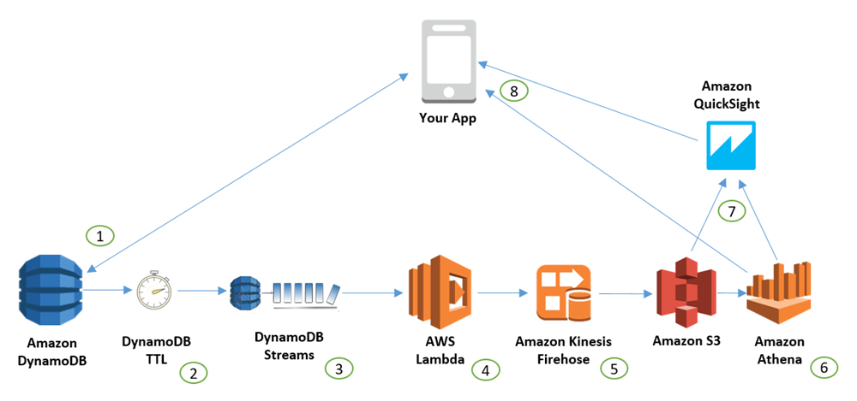
Image 4. Amazon DynamoDB data by using Amazon Athena. Taken from: https://aws.amazon.com/es/blogs/database/how-to-perform-advanced-analytics-and-build-visualizations-of-your-amazon-dynamodb-data-by-using-amazon-athena/
In addition, some advantages of Cassandra for data analysis are the following:
- Fast and consistent performance: Amazon DynamoDB is designed with the goal of delivering fast and consistent performance to all applications at any scale.
- Ecalable: When creating a table, you just need to specify how much request capacity you need.
- Fully managed: It is a fully managed cloud NoSQL database service, you just need to create a database, set the performance and the service will take care of the rest.
- Event-driven programming: DynamoDB integrates with AWS Lambda to provide triggers that allow you to create applications that automatically react when data changes occur.
- Thorough access control: Amazon DynamoDB integrates with AWS Identity and Access Management (IAM) to provide granular access control for users within your organization.
- Flexible: DynamoDB supports document and key-value data structures, flexibility that enables you to design the best architecture for your application.

When to use DynamoDB?
- In case the analyst is looking for a database that can handle simple key-value queries but those queries are very large in number.
- In case the analyst is working with OLTP workload like online ticket booking or banking where the data needs to be highly consistent.

- HBase
HBase is an open-source project maintained by the Apache Foundation that provides a distributed columnar database built on top of the Hadoop filesystem that can scale horizontally. HBase uses a data model very similar to the Google Big Table designed to provide random access to a very large amount of structured data. The objective of the HBase project is the storage of very large tables, of billions of rows by millions of columns, for this it stores the data by key-value pairs. Searching for keys in HBase is very fast. Writing also because it is practically done in memory. [8]
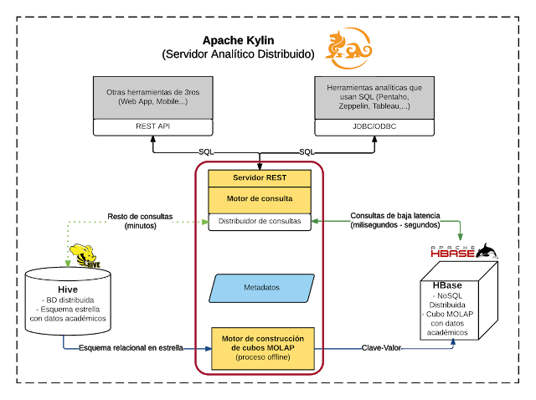
Apache Hadoop allows the analyst to easily combine massive parallel analysis with fast data access. Apache HBase's data model, performance, and fault tolerance are ideal for workloads in ad technology, web analytics and financial services applications with time series data, and more.
Image 5. Analysis Big Data OLAP on Hadoop with Apache Kylin. Taken from: https://todobi.com/analysis-big-data-olap-sobre-hadoop-con/
In addition, some advantages of HBase for data analysis are the following:
- Consistent reading and writing
- Horizontal scalability
- Automatic sharding: this is the horizontal partitioning of a table into regions in order to increase search performance and data access.
- Automatic error detection in RegionServers.
- Integration with HDFS, MapReduce, Java API, Thrift / REST API.
When to use HBase?
- The analyst should have at least petabytes of data to be processed. If your data volume is small, then you will not get the desired results.
- If the use case requires random and real-time access to the data, then HBase will be the appropriate option.
- If the analyst wants to easily store real-time messages for billions of people.

- CONCLUSIONS
There are many databases used for data analysis. Both relational and non-relational databases can work, even some non-relational databases combine SQL tools to achieve better result.
Some non-relational databases have integrated tools that facilitate data analysis, others require to be connected to the analysis tools or to migrate to another tool for this to be possible.
Each database offers different characteristics that are adapted to the needs of each business.
Before choosing a non-relational database, it is necessary to take into consideration the conditions that our database will have and verify if the database complies with what we require.
REFERENCES
[1] "¿Qué es Análisis de datos? - Definición en WhatIs.com", SearchDataCenter&nbsp;en&nbsp;Español, 2021. [Online]. Available: https://searchdatacenter.techtarget.com/es/definicion/Analisis-de-Datos. [Accessed: 18- Mar- 2021].
[2] "Should You Use MongoDB or SQL Databases For Analytics?", The Holistics Blog, 2021. [Online]. Available: https://www.holistics.io/blog/should-you-use-mongodb-or-sql-databases-for-analytics/. [Accessed: 14- Mar- 2021].
[3] "La base de datos líder del mercado para aplicaciones modernas", MongoDB, 2021. [Online]. Available: https://www.mongodb.com/es. [Accessed: 17- Mar- 2021].
[4] A. Turner, "Apache Cassandra: An Introductory Guide | ScyllaDB", ScyllaDB, 2021. [Online]. Available: https://www.scylladb.com/resources/introduction-to-apache-cassandra/. [Accessed: 17- Mar- 2021].
[5] "¿Qué es Elasticsearch?", Elastic, 2021. [Online]. Available: https://www.elastic.co/es/what-is/elasticsearch. [Accessed: 18- Mar- 2021].
[6] "AWS | Servicio de base de datos gestionada NoSQL (DynamoDB)", Amazon Web Services, Inc., 2021. [Online]. Available: https://aws.amazon.com/es/dynamodb/. [Accessed: 18- Mar- 2021].
[7] u. DynamoDB, "Características de Amazon DynamoDB | Base de datos de clave-valor NoSQL | Amazon Web Services", Amazon Web Services, Inc., 2021. [Online]. Available: https://aws.amazon.com/es/dynamodb/features/. [Accessed: 18- Mar- 2021].
[8] "Apache HBase", Big Data Dummy, 2021. [Online]. Available: https://bigdatadummy.wordpress.com/2017/01/25/hbase/. [Accessed: 18- Mar- 2021].

